Verify Login without data

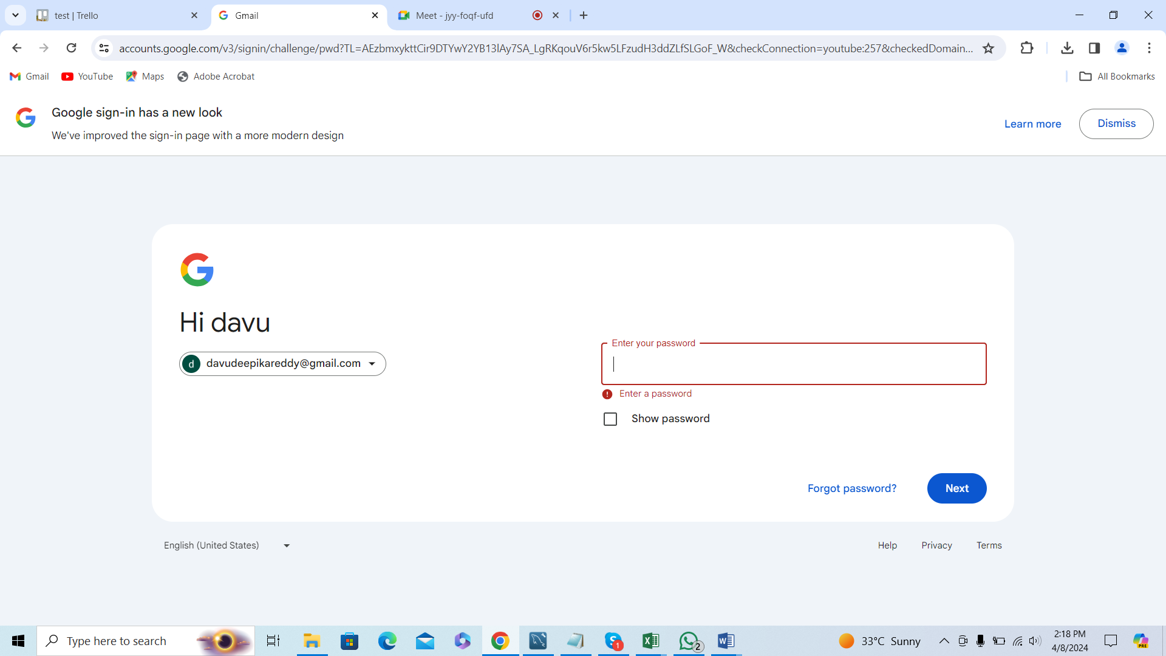

Error message is displayed